Project Report

**Ecommerce Website**

Web Programming Languages

Fall Semester 2024

Group Members: Hamood Ahmed (19694),Muhammad Abdullah (17605) and Huzaifa (23477)



### Computer Science Department

**IQRA University**

Gulshan Campus, Karachi

http://www.iqra.edu.pk

**Submitted To: Dr.Noman Islam**

|  |  |  |  |
| --- | --- | --- | --- |
| **Project Index** | | | |
| **S.No. #** | **Topics** | **Signature** | **Remarks** |
| 1 | Acknowledgement 🡪 Page #(3) |  |  |
|
|
| 2 | Theme 🡪 Page #(4-5) |  |  |
|
|
| 3 | Source Code 🡪 Page #(6-35) |  |  |
|
|
| 4 | Output 🡪 Page # (36-40) |  |  |
|
|
| 5 | Important Definitions/Commands 🡪 Page # (41) |  |  |
|
|
| 6 |  |  |  |
|
|

**Acknowledgement:**

"I would like to thank everyone who contributed to the success of my E-Commerce Website Project. Special thanks to my teacher, **Mr[Noman Islam]** ,for their invaluable guidance, and to my teammates, [**Hamood Ahmed, Huzaifa and Muhammad Abdullah**], for their hard work. I am also grateful to [Daraz Sellers] for their generous support. Lastly, I appreciate the encouragement from my family and friends."

**Theme**

1. **Introduction**

The goal of this project is to create a comprehensive e-commerce platform that will allow clients to easily buy a variety of shopping items, such as shopping carts, groceries, and fashionable clothing. This website's main objective is to provide a dependable, safe, and user-friendly online marketplace where customers can purchase a range of premium goods at affordable costs.

1. **Problem Statement**

Due to its convenience, e-commerce is becoming more and more popular in today's fast-paced world. Finding a trustworthy platform that offers a variety of product categories is still difficult for many customers, particularly when it comes to shopping accessories, food, and designer clothing. Consumers frequently worry about the dependability, quality, and cost of internet retailers, especially when purchasing commonplace goods like food and clothing. By providing a carefully chosen range of goods from reputable vendors, the platform seeks to foster confidence while guaranteeing both quality and cost.

1. **Objectives of the E-Commerce Website**

This project's primary goal is to create an online store that acts as a one-stop shop for customers wishing to buy food, shopping carts, and designer clothing. The main goals of the website are:

* **Simple Shopping Experience:** Offer a user-friendly and intuitive interface so that clients can browse and buy things with ease. The website will have rapid checkout choices, sophisticated search filters, and well-organized categories.
* **Wide Selection of Products:** Provide a range of premium goods in three main categories: shopping carts, groceries, and fashionable clothing. Items in each category will range from fashionable clothing to daily necessities.

#### ****Features of the Website****

A number of features will be included in the e-commerce website to improve consumers' purchasing experiences. Customers seeking groceries, fashion, and shopping accessories will be served by these features:

* **Product Catalog and Search Features:** A thorough catalog of goods, including shopping carts, groceries, and designer clothing, will be arranged by category. Customers will be able to filter products by price, size, brand, and other criteria using sophisticated search features.
* **Secure Payment Gateway:** To protect the privacy of user data, the platform will incorporate secure payment methods such as mobile wallets, credit/debit card payments, and other reliable techniques.

#### 

#### 5. ****Technology Stack****

Modern web development technologies will be used to create the website, guaranteeing its security, scalability, and responsiveness. The following will be part of the project's technology stack:

• **Frontend:** frameworks like React or Angular for a dynamic user interface, HTML5, CSS3, and JavaScript.

• **Backend:** For server-side programming that ensures effective management of user requests, transactions, and data processing, utilize PHP, Node.js, or Django.

• **Database:** MongoDB or MySQL for storing orders, reviews, customer information, and product details.

#### 6. ****Expected Outcomes****

The creation of this e-commerce platform will result in a flexible shopping option that blends variety, affordability, and ease of use. The anticipated results consist of:

* **Increased Adoption of Online Shopping:** By providing a straightforward, safe, and affordable online shopping experience, the platform will inspire more customers to adopt online shopping for groceries, fashion, and shopping carts.
* **Economic Growth for Suppliers:** The platform will help manufacturers and suppliers expand their reach and sales potential by putting them in direct contact with end users, which will promote company growth.

**Source Code**

**App.js (File):**

import { BrowserRouter as Router } from 'react-router-dom';

import { Route , Routes} from 'react-router-dom';

import './App.css';

import 'bootstrap/dist/css/bootstrap.min.css';

import Home from '../routes/Home';

import Header from '../components/Header/Header';

import Footer from '../components/Footer/Footer';

import ManageAccount from '../components/Account/ManageAccount/ManageAccount';

import MyAccount from '../components/Account/MyAccount/MyAccount';

import Shop from '../components/Shop/Shop';

import ItemView from '../routes/ItemView';

import CategoryView from '../routes/CategoryView';

import SearchView from '../routes/Search';

import CartItemsProvider from '../Context/CartItemsProvider';

import Login from '../components/Authentication/Login/Login';

import Register from '../components/Authentication/Register/Register';

import Wishlist from '../components/Wishlist';

import WishItemsProvider from '../Context/WishItemsProvider';

import DrawerNav from '../components/Nav/DrawerNav/DrawerNav';

import Checkout from '../components/Checkout/Checkout';

import SearchProvider from '../Context/SearchProvider';

function App() {

return (

<CartItemsProvider>

<WishItemsProvider>

<SearchProvider>

<Router >

<Header />

<Routes>

<Route index element={<Home />}/>

<Route path="/account">

<Route path="me" element={<MyAccount/>}/>

<Route path="manage" element={<ManageAccount/>}/>

<Route path="login" element={<Login />}/>

<Route path="register" element={<Register />}/>

<Route path="*" element={<Login />}/>

</Route>

<Route path="/shop" element={<Shop />}/>

<Route path="/category">

<Route path=":id" element={<CategoryView />}/>

</Route>

<Route path="/item">

<Route path="/item/men">

<Route path=":id" element={<ItemView />}/>

</Route>

<Route path="/item/women">

<Route path=":id" element={<ItemView />}/>

</Route>

<Route path="/item/kids">

<Route path=":id" element={<ItemView />}/>

</Route>

<Route path="/item/featured">

<Route path=":id" element={<ItemView />}/>

</Route>

</Route>

<Route path="/wishlist" element={<Wishlist />} />

<Route path="/search/*" element={<SearchView />} />

</Routes>

<Footer />

<Routes>

<Route path="/admin" element={<Wishlist />} />

</Routes>

</Router>

</SearchProvider>

</WishItemsProvider>

</CartItemsProvider>

);

}

export default App;

**App.css**

@import url('https://fonts.googleapis.com/css2?family=Open+Sans:wght@300&family=Roboto:wght@500&family=Ubuntu:wght@500&display=swap');

* {

font-family: 'Roboto', sans-serif;

}

a {

text-decoration: none;

color: #000;

}

a:hover {

text-decoration: none;

}

**Header.js**

import Navbottom from '../Nav/Nav-Links/NavLinks';

import Navtop from '../Nav/Container/Container';

import './Header.css'

const Header = () => {

return (

<div className='header__container'>

<Navtop />

<Navbottom />

</div>

);

}

export default Header;

**Header.css**

.header__container {

height: auto;

width: 100%;

background-color: #ffffff;

font-family: 'Roboto', sans-serif;

box-shadow: 0px -6px 10px 0px;

}

**Footer.js**

import './Footer.css'

import LocalPhoneIcon from '@mui/icons-material/LocalPhone';

import EmailIcon from '@mui/icons-material/Email';

import LocationOnIcon from '@mui/icons-material/LocationOn';

import InstagramIcon from '@mui/icons-material/Instagram';

import YouTubeIcon from '@mui/icons-material/YouTube';

import TwitterIcon from '@mui/icons-material/Twitter';

import TelegramIcon from '@mui/icons-material/Telegram';

import PinterestIcon from '@mui/icons-material/Pinterest';

const Footer = () => {

return (

<footer>

<div className="footer__container">

<div className="footer__items__container">

<div className="footer__help__container">

<div className="footer__help__header">

<h1>Help</h1>

</div>

<ul className="fotter__help__links">

<li className="help__link">

<a href="/"> Shipping</a>

</li>

<li className="help__link">

<a href="/">Refund</a>

</li>

<li className="help__link">

<a href="/">FAQ</a>

</li>

<li className="help__link">

<a href="/">Accessiblity</a>

</li>

</ul>

</div>

<div className="footer__contact__container">

<div className="footer__contact__header">

<h1>Contact Us</h1>

</div>

<ul className="footer__contacts">

<li className="footer__contact">

<LocalPhoneIcon /> <span>+123 4567 890</span>

</li>

<li className="footer__contact">

<EmailIcon /> <span>shop@shema.com</span>

</li>

<li className="footer__contact">

<LocationOnIcon /> <span>Addis Ababa, Ethiopia</span>

</li>

</ul>

</div>

<div className="footer__social__link__container">

<div className="footer__social__link__header">

<h1>Stay Connected</h1>

</div>

<ul className="footer__social__links">

<li className="social__link">

<TwitterIcon />

</li>

<li className="social__link">

<InstagramIcon />

</li>

<li className="social__link">

<YouTubeIcon />

</li>

<li className="social__link">

<TelegramIcon />

</li>

<li className="social__link">

<PinterestIcon />

</li>

</ul>

</div>

</div>

<div className="fotter__copyright__container">

<ul className='nav'>

<li className="footer__copyright">©2022 Shema Ltd. |</li>

<li className="footer__terms__condition"> | Terms & Condition |</li>

<li className="footer__privacy__policy">| Privacy Policy</li>

</ul>

</div>

</div>

</footer>

);

}

export default Footer;

**Footer.css**

.footer__container {

height: auto;

width: 100%;

background-color: #FFE26E;

display: flex;

flex-direction: column;

}

.footer__items__container {

height: 100%;

width: 100%;

display: flex;

justify-content: space-between;

flex-direction: row;

flex-wrap: wrap;

align-items: center;

}

.footer__help__container {

width: 300px;

height: 180px;

display: flex;

justify-content: center;

flex-direction: column;

align-items: center;

}

.footer__help__header {

height: 40%;

width: 70%;

margin: auto;

display: flex;

}

.footer__help__header h1{

font-size: 1.3rem;

font-weight: 600;

align-self: center;

}

.fotter__help__links {

margin: 0%;

padding: 0%;

height: 70%;

width: 70%;

list-style-type: none;

display: flex;

flex-direction: column;

}

.footer__contact__container {

width: 300px;

height: 180px;

display: flex;

justify-content: center;

flex-direction: column;

align-items: center;

}

.footer__contact__header {

height: 40%;

width: 70%;

display: flex;

justify-self: center;

align-self: center;

}

.footer__contact__header h1{

font-size: 1.3rem;

font-weight: 600;

align-self: center;

}

.footer__contacts {

margin: 0%;

padding: 0%;

height: 100%;

width: 70%;

list-style-type: none;

display: flex;

flex-direction: column;

}

.footer__contact {

width: 100%;

height: 30%;

}

.footer__social__link__container {

width: 300px;

height: 180px;

display: flex;

justify-content: center;

flex-direction: column;

align-items: center

}

.footer__social__link__header {

height: 40%;

width: 100%;

display: flex;

}

.footer__social__link__header h1 {

font-size: 1.3rem;

font-weight: 600;

align-self: center;

}

.footer__social__links {

margin: 0%;

padding: 0%;

height: 70%;

width: 100%;

list-style-type: none;

display: flex;

flex-direction: row;

}

.social__link {

width: 12%;

}

.fotter__copyright__container {

height: auto;

width: 100%;

background-color: black;

display: flex;

color: #FFE26E;

display: flex;

justify-content: center;

align-items: center;

flex-direction: row;

flex-wrap: wrap;

}

**ManageAccount.js**

import Account from '../Account';

import './ManageAccount.css'

const ManageAccount = () => {

return (

<Account>

<div className="manage__account__container">

<div className="edit__account__container">

<div className="edit__account">

<div className="edit__account__header">Edit account</div>

<div className="edit__account__form__container">

<div className="edit__account__form">

<div className="fname__input__container edit__input__container">

<label className="fname__label input__label">First name</label>

<input type="text" className="fname__input edit__account__input" />

</div>

<div className="lname__input__container edit__input__container">

<label className="lname__label input__label">Last name</label>

<input type="text" className="lname__input edit__account__input"/>

</div>

<div className="save__changes__button__container">

<button className="save__changes__button" >Save Changes</button>

</div>

</div>

</div>

</div>

</div>

<div className="separator__line"></div>

<div className="delete_account__container">

<div className="delete__account">

<div className="delete__account__header">

Delete account

</div>

<div className="delete__account__prompt">Do you want to cancel subscription?</div>

<div className="delete__account__button__container">

<button className="delete__account__button" >Delete Account</button>

</div>

</div>

</div>

</div>

</Account>

);

}

export default ManageAccount;

**ManageAccount.css**

.manage__account__container {

height: auto;

width: 100%;

display: flex;

flex-direction: column;

justify-content: flex-start;

align-items: flex-start;

margin-top: 20px;

}

.edit__account__container {

width: 100%;

height: 300px;

}

.edit__account {

width: 250px;

height: 100%;

}

.edit__account__header {

width:100%;

height: 20%;

font-size: 1.7rem;

font-weight: bolder;

}

.edit__account__form__container {

width:100%;

height: 80%;

}

.edit__account__form {

width:100%;

height: 100%;

}

.edit__input__container {

height:35%;

width: 100%;

}

.edit__account__input {

height: 50%;

width: 100%;

}

.save__changes__button__container {

height: 30%;

width: 100%;

display: flex;

justify-content: flex-start;

align-items: center;

}

.save__changes__button {

height: 60%;

width: 50%;

font-size: 1rem;

background-color: #FFE26E;

border-color: #FFE26E;

border-style: dashed;

font-weight:bold;

}

.separator__line {

margin-top: 20px;

height: 5px;

width: 50%;

background-color: #FFE26E;

}

/* Delete account form */

.delete_account__container {

width: 250px;

height: 200px;

display: flex;

justify-content: flex-start;

align-items: center;

}

.delete__account {

height: 100%;

width: 100%;

display: flex;

justify-content: flex-start;

align-self: flex-start;

flex-direction: column;

}

.delete__account__header {

width: 100%;

height: 30%;

display: flex;

justify-content: flex-start;

align-items: center;

font-size: 1.7rem;

font-weight: bolder;

}

.delete__account__prompt {

height: 35%;

width: 100%;

}

.delete__account__button__container {

height: 35%;

width: 100%;

display: flex;

justify-content: flex-start;

}

.delete__account__button {

height: 45px;

width: 160px;

font-size: 1rem;

background-color: #ff6e6e;

border-color: #ff6e6e;

border-style: dashed;

font-weight:bold;

}

**MyAccount.js**

import Account from '../Account';

import './MyAccount.css';

import { Link } from 'react-router-dom'

const MyAccount = () => {

return (

<Account>

<div className="order__history__container">

<div className="order__history">

<div className="order__history__header">Order History</div>

<div className="order__history__detail">You have not place any orders yet</div>

</div>

</div>

<div className="account__details__container">

<div className="account__details__header">

<div className="details__header">Account Details</div>

<div className="logout__action">Logout</div>

</div>

<div className="account__details">

<div className="account__holder__name">Account holder name</div>

<div className="account__holder__email">Account holder email</div>

<div className="manage__account__action">

<Link to="/account/manage">Manage account</Link>

</div>

</div>

</div>

</Account>

);

}

export default MyAccount;

**MyAccount.css**

.order__history__container {

height: 200px;

width: 70%;

display: flex;

flex-direction: column;

justify-content: flex-start;

align-self: flex-start;

}

.order__history {

height: auto;

width: 100%;

display: flex;

flex-direction: column;

}

.order__history__header {

width: 100%;

height: 50px;

font-size: 1.7rem;

font-weight: bolder;

}

.order__history__detail {

width: 100%;

height: 50px;

}

.account__details__container {

width: 30%;

height: 200px;

}

.account__details__header {

width: 100%;

height: 50px;

display: flex;

flex-direction: row;

justify-content: space-between;

align-items: center;

}

@media (max-width: 780px) {

.account__details__header {

flex-direction: column;

height: auto;

align-items: flex-start;

}

}

.details__header {

width: 80%;

height: auto;

font-size: 1.7rem;

font-weight: bolder;

}

.logout__action {

width: 20%;

height: auto;

}

**Shop.js**

import { useEffect, useState } from 'react';

import { TabTitle } from '../../utils/General';

import axios from "axios";

import ShopCategory from './Container/ShopCategory';

import './Shop.css';

import ReactLoading from 'react-loading';

const Shop = () => {

TabTitle("Shop - SHEMA")

const [ menItems, setMenItems ] = useState()

const [ womenItems, setWomenItems ] = useState()

const [ kidsItems, setKidsItems ] = useState()

const [ loading , setLoading ] = useState(true)

useEffect(() => {

axios.get("https://shema-backend.vercel.app/api/items")

.then(res => {

setMenItems(res.data.filter((item) => item.category === "men"))

setKidsItems(res.data.filter((item) => item.category === "kids" ))

setWomenItems(res.data.filter((item) => item.category === "women"))

setLoading(false)

})

.catch(err => console.log(err))

window.scrollTo(0, 0)

}, [])

return (

<div className="shop__contianer">

{loading && <ReactLoading type="balls" color='#FFE26E' height={100} width={100} className='container h-100 w-10 justify-self-center align-self-center m-auto'/>}

{menItems && <ShopCategory name="Men" key="men" items={menItems}/>}

{womenItems && <ShopCategory name="Women" key="women" items={womenItems}/>}

{kidsItems && <ShopCategory name="Kids" key="kids" items={kidsItems}/>}

</div>

);

}

export default Shop;

**Shop.css**

.shop__contianer {

height: auto;

min-height: 80vh;

width: 100%;

display: flex;

flex-direction: column;

}

**Item.js**

import ItemCarousel from './Carousel/ItemCarousel';

import Description from './Description/Description';

import Detail from './Detail/Detail';

import './Item.css';

import Related from './Related/Related';

const Item = (props) => {

return (

<div className="item__container">

<div className="detail__and__carousel__container">

<ItemCarousel item={props.item}/>

<Detail item={props.item}/>

</div>

<div className="item__description__container">

<Description item={props.item}/>

</div>

<div className="related__items__container">

<Related category={props.item.category}/>

</div>

</div>

);

}

export default Item;

**Item.css**

.item__container {

height: auto;

width: 100%;

}

.detail__and__carousel__container {

height: auto;

width: 100%;

display: flex;

justify-content: center;

align-items: center;

flex-direction: row;

flex-wrap: wrap;

margin-top: 20px;

}

.item__description__container {

height: auto;

width: 100%;

}

.related__items__container {

height: auto;

width: 100%;

}

**Category.js**

import './Category.css';

import ItemCard from '../Card/ItemCard/ItemCard';

import { useState } from 'react';

import Box from '@mui/material/Box';

import InputLabel from '@mui/material/InputLabel';

import MenuItem from '@mui/material/MenuItem';

import FormControl from '@mui/material/FormControl';

import Select from '@mui/material/Select';

import { TabTitle } from '../../utils/General';

import { Button } from '@mui/material';

const Category = (props) => {

TabTitle(props.name)

const [show, setShow] = useState('All');

const [filter, setFilter] = useState('Latest');

const handleShowChange = (event) => {

setShow(event.target.value);

};

const handleFilterChange = (event) => {

setFilter(event.target.value);

};

return (

<div className="category__container">

<div className="category">

<div className="category__header__container">

<div className="category__header__big">

<div className="category__header">

<h2>{props.name}</h2>

</div>

<div className="category__header__line"></div>

</div>

<div className="category__sort">

<div className="show__filter">

<Box sx={{ minWidth: 100} }>

<FormControl fullWidth size="small">

<InputLabel>Show</InputLabel>

<Select

value={show}

label="Show"

onChange={handleShowChange}

>

<MenuItem value={'All'}>All</MenuItem>

</Select>

</FormControl>

</Box>

</div>

<div className="filter__by">

<div className="show__filter">

<Box sx={{ width: 120} }>

<FormControl fullWidth size="small">

<InputLabel>Filter by</InputLabel>

<Select

value={filter}

label="Filter"

onChange={handleFilterChange}

>

<MenuItem value={'Latest'}>Latest</MenuItem>

</Select>

</FormControl>

</Box>

</div>

</div>

</div>

</div>

<div className="category__card__container">

<div className="category__product__card">

{props.items.map((data) => <ItemCard item={data} category={props.category}/>)}

<div className="show__more__action">

<Button variant='outlined' sx={[ {width: '200px', height: '50px', borderRadius: '20px' , fontWeight: '700', backgroundColor: '#FFE26E', borderColor: '#FFE26E', color: 'black' }, {'&:hover': { borderColor: '#FFE26E', backgroundColor: "none" }}]}>Show more</Button>

</div>

</div>

</div>

</div>

</div>

);

}

export default Category;

**Category.css**

.category__container {

height: auto;

width: 100%;

margin: 10px auto;

}

.category {

height: auto;

width: 100%;

display: flex;

justify-content: center;

flex-direction: column;

}

.category__header__container {

height: 200px;

width: 90%;

margin: auto;

display: flex;

justify-content: center;

align-items:center;

flex-direction: column;

}

.category__header__big {

height: 40%;

width: 100%;

display: flex;

justify-content: center;

align-items: center;

flex-direction: column;

}

.category__header {

align-self: flex-start;

}

.category__header__line {

width: 120px;

height: 6px;

background-color: #FFE26E;

align-self: flex-start;

border-radius: 25px;

}

.category__sort {

height: auto;

width: 30%;

display: flex;

justify-content: space-around;

align-items: center;

flex-direction: row;

flex-wrap: wrap;

align-self: flex-end;

}

.category__card__container {

height: auto;

width: 100%;

display: flex;

justify-content: center;

align-items: center;

}

.category__product__card {

height: auto;

width: 95%;

display: flex;

justify-content: center;

flex-wrap: wrap;

}

.show__more__action {

width: 100%;

height: 200px;

bottom: 0%;

display: flex;

justify-content: center;

align-items: center;

}

.show__more__button {

width: 200px;

height: 25%;

border-radius: 20px;

font-size: 1rem;

background-color: #FFE26E;

border-color: #FFE26E;

border-style: dashed;

font-weight:bold;

}

For Search Folder (index.css and index.js files)

**Index.js**

import { useEffect } from 'react';

import { useContext } from 'react';

import { useSearchParams } from 'react-router-dom';

import { SearchContext } from '../../Context/SearchContext';

import './index.css'

const Search = () => {

const search = useContext(SearchContext)

const [ searchParam, setSearchParam ] = useSearchParams()

const searchQuery = {

query: search.searchQuery

}

useEffect(() => {

setSearchParam(searchQuery, { replace: true })

}, [searchQuery.query])

return (

<div className="search__container">

<div className="search__container__header">

<h1>No results found for "{search.searchQuery}"</h1>

</div>

</div>

);

}

export default Search;

**Index.css**

.search__container {

width: 100%;

height: 70vh;

display: flex;

justify-content: center;

align-items: center;

}

.search__container__header {

height: 100px;

display: flex;

justify-content: center;

align-items: center;

}

**For CartItems (Cart.js and Cart.css files)**

**Cart.js**

import { Fragment, useContext, useState } from 'react';

import { CartItemsContext } from '../../../Context/CartItemsContext';

import Box from '@mui/material/Box';

import Modal from '@mui/material/Modal';

import ShoppingCartIcon from '@mui/icons-material/ShoppingCart';

import Badge from '@mui/material/Badge';

import CartCard from './CartCard/CartCard';

import './Cart.css'

import Button from '@mui/material/Button';

import axios from 'axios';

const style = {

position: 'absolute',

top: '50%',

left: '50%',

transform: 'translate(-50%, -50%)',

minWidth: '350px',

width: '45%',

height: '400px',

bgcolor: 'background.paper',

border: '5px solid #FFE26E',

borderRadius: '15px',

boxShadow: 24,

p: 4,

};

const Cart = () => {

const [open, setOpen] = useState(false);

const handleOpen = () => setOpen(true);

const handleClose = () => setOpen(false);

const [ openCheckoutModal, setOpenCheckoutModal] = useState(false);

const handleCheckoutOpen = () => setOpenCheckoutModal(true);

const handleCheckoutClose = () => setOpenCheckoutModal(false);

const cartItems = useContext(CartItemsContext);

const handleCheckout = async () => {

if(cartItems.totalAmount > 0){

const config = {

reason: 'checkout',

amount: cartItems.totalAmount

}

await axios.post("http://localhost:5000/api/payment", config)

.then((res) => {

console.log(res.data)

window.location.replace(res.data)

handleCheckoutOpen()

}

)

.catch((err) => console.log(err))

}

else {

return

}

}

return (

<Fragment>

<Badge badgeContent={cartItems.items.length} color="error">

<ShoppingCartIcon color="black" onClick={handleOpen} sx={{ width: '35px'}}/>

</Badge>

<Modal

open={open}

onClose={handleClose}

>

<Box sx={style}>

<div className="cart__header">

<h2>Your Cart</h2>

</div>

<div className="cart__items__container">

<div className="cartItems">

{cartItems.items.length===0?

<div className="cart__empty"> Empty cart!</div> :

<div className="shop__cart__items">

{cartItems.items.map((item) => <CartCard key={item._id} item={item}/>)}

</div>

}

{cartItems.items.length > 0 &&

<div className="options">

<div className="total__amount">

<div className="total__amount__label">Total Amount:</div>

<div className="total__amount__value">${cartItems.totalAmount}.00</div>

</div>

<div className="checkout">

<Button variant="outlined" onClick={handleCheckout}>Checkout</Button>

</div>

</div>

}

</div>

</div>

</Box>

</Modal>

<Modal

open={openCheckoutModal}

onClose={handleCheckoutClose}

>

<Box sx={style}>

<div className="d-flex w-100 h-100 justify-content-center align-items-center">

<h2>Your checkout was successful</h2>

</div>

</Box>

</Modal>

</Fragment>

);

}

export default Cart;

**Cart.css**

.cart__items__container {

width: 100%;

min-width: 200px;

min-height: 100px;

height: 85%;

overflow: auto;

display: flex;

flex-direction: column;

}

.cartItems{

width: 100%;

height: auto;

display: flex;

justify-content: flex-start;

align-items: flex-start;

position: relative;

flex-direction: column;

}

.cart__header {

width: 100%;

height: 50px;

text-align: center;

}

.shop__cart__items {

width: 100%;

height:90%;

margin-bottom: 50px;

}

.cart__empty {

height: 250px;

width: 100%;

display: flex;

justify-content: center;

align-items: center;

font-size: 1.4rem;

font-weight: 300;

}

.options {

width: 100%;

height: auto;

}

.total__amount {

width: 100%;

height: 50px;

display: flex;

justify-content: space-between;

flex-direction: row;

background-color: #f1f1f1;

/* position: absolute; */

margin: auto;

bottom: 0%;

}

.total__amount__label {

width: 80%;

height: 100%;

display: flex;

justify-content: flex-start;

align-items: center;

margin: auto 10px;

font-weight: 700;

}

.total__amount__value {

width: 20%;

min-width: 100px;

height: 100%;

display: flex;

justify-content: flex-start;

align-items: center;

font-weight: 600;

}

.checkout {

width: 100%;

height: 50px;

display: flex;

justify-content: flex-end;

align-items: center;

}

**LoginCard.js**

import { Link } from 'react-router-dom';

import './LoginCard.css';

const LoginCard = () => {

return (

<div className="login__card__container">

<div className="login__card">

<div className="login__header">

<h1>Login</h1>

</div>

<div className="login__inputs">

<div className="email__input__container input__container">

<label className="email__label input__label">Email</label>

<input type="email" className="email__input login__input" placeholder='example@gmail.com' />

</div>

<div className="password__input__container input__container">

<label className="password__label input__label" >Password</label>

<input type="password" className="password__input login__input" placeholder='**********'/>

</div>

<div className="login__button__container">

<button className="login__button" >LOGIN</button>

</div>

</div>

<div className="login__other__actions">

<div className="login__forgot__password">Forgot password?</div>

<div className="login__new__account">Don't have account? <Link to="/account/register">Create account</Link> </div>

</div>

</div>

</div>

);

}

export default LoginCard;

**LoginCard.css**

.login__card__container {

height: 500px;

width:420px;

margin: auto;

box-shadow: 0px 2px 5px -2px;

}

.login__card {

height: 100%;

width: 90%;

margin: auto;

padding: 10px;

}

.login__header {

height: 25%;

width: 100%;

display: flex;

justify-content: flex-start;

align-items: center;

}

.login__header h1 {

font-size: 2.5rem;

font-weight: bolder;

}

.login__inputs {

height: 60%;

width: 100%;

}

.input__container {

height: 35%;

width: 100%;

display: flex;

justify-content: flex-start;

flex-direction: column;

}

.input__label {

height: 40%;

width: 100%;

font-size: 1.1rem;

font-weight: 500;

}

.login__input {

width: 100%;

height: 50%;

display: flex;

justify-content: center;

align-items: center;

}

.login__button__container {

height: 30%;

width: 100%;

display: flex;

justify-content: center;

align-items: center;

}

.login__button {

height: 60%;

width: 100%;

font-size: 1.1rem;

background-color: #FFE26E;

border-color: #FFE26E;

border-style: dashed;

font-weight:bold;

}

.login__other__actions {

height: 20%;

width: 100%;

}

**RegisterCard.js**

import { Link } from 'react-router-dom';

import './RegisterCard.css';

const RegisterCard = () => {

return (

<div className="register__card__container">

<div className="register__card">

<div className="register__header">

<h1>Create Account</h1>

</div>

<div className="register__inputs">

<div className="fname__input__container reg__input__container">

<label className="fname__label input__label">First name</label>

<input type="text" className="fname__input register__input" />

</div>

<div className="lname__input__container reg__input__container">

<label className="lname__label input__label">Last name</label>

<input type="text" className="lname__input register__input"/>

</div>

<div className="email__input__container reg__input__container">

<label className="email__label input__label">Email</label>

<input type="email" className="email__input register__input" placeholder='example@gmail.com' />

</div>

<div className="password__input__container reg__input__container">

<label className="password__label input__label">Password</label>

<input type="password" className="password__input register__input" />

</div>

<div className="register__button__container">

<button className="register__button" >Create Account</button>

</div>

</div>

<div className="register__other__actions">

<div className="register__login__account">Already have account? <Link to="/account/login">Login</Link></div>

</div>

</div>

</div>

);

}

export default RegisterCard;

**RegisterCard.css**

.register__card__container {

height: 650px;

width: 420px;

margin: auto;

box-shadow: 0px 2px 5px -2px;

}

.register__card {

height: 100%;

width: 90%;

margin: auto;

padding: 10px;

}

.register__header {

height: 20%;

width: 100%;

display: flex;

justify-content: flex-start;

align-items: center;

}

.register__header h1 {

font-size: 2.5rem;

font-weight: bolder;

}

.register__inputs {

height: 70%;

width: 100%;

}

.reg__input__container {

height:19%;

width: 100%;

display: flex;

justify-content: flex-start;

flex-direction: column;

}

.input__label {

height: 40%;

width: 100%;

font-size: 1.1rem;

font-weight: 500;

}

.register__input {

width: 100%;

height: 50%;

}

.register__button__container {

height: 25%;

width: 100%;

display: flex;

justify-content: center;

align-items: center;

}

.register__button {

height: 50%;

width: 100%;

font-size: 1.1rem;

background-color: #FFE26E;

border-color: #FFE26E;

border-style: dashed;

font-weight:bold;

}

.register__other__actions {

height: 20%;

width: 100%;

}

**In the WishList Two Files(WishCard.js and WishCard.css) provided**

**WishCard.js**

import { useContext } from 'react';

import HighlightOffIcon from '@mui/icons-material/HighlightOff';

import { IconButton } from '@mui/material';

import './WishCard.css'

import { Button } from '@mui/material';

import { WishItemsContext } from '../../../Context/WishItemsContext';

const WishCard = (props) => {

const wishItems = useContext(WishItemsContext)

const handelRemoveItem = () => {

wishItems.removeItem(props.item)

}

const handelAddToCart = () => {

wishItems.addToCart(props.item)

};

return (

<div className="wishcard">

<div className="wish__remove__item__icon">

<IconButton>

<HighlightOffIcon onClick={handelRemoveItem}/>

</IconButton>

</div>

<div className="wish__item__image">

<img src={`https://shema-ecommerce.herokuapp.com/${props.item.category}/${props.item.image[0].filename}`} alt="item" className="wish__image"/>

</div>

<div className="wish__item__name">{props.item.name}</div>

<div className="wish__item__price">${props.item.price}</div>

<div className="add__to__cart">

<Button variant='outlined' onClick={handelAddToCart} sx={[{'&:hover': { backgroundColor: '#FFE26E', borderColor: '#FFE26E', color: 'black'}, borderColor: 'black', backgroundColor: "black" , color: "#FFE26E"}]}>Add to cart</Button>

</div>

</div>

);

}

export default WishCard;

**WishCard.css**

.wishcard {

width: 90%;

min-height: 100px;

height: auto;

display: flex;

justify-content: space-around;

flex-direction: row;

align-items: center;

flex-wrap: wrap;

position: relative;

background-color: rgb(255, 255, 255);

margin: 10px auto;

}

/* .wishcard > div {

width: 110px;

height: 50px;

height: auto;

display: flex;

justify-content: center;

align-items: center;

} */

.wish__item__image {

width: 110px;

height: auto;

height: auto;

display: flex;

justify-content: center;

align-items: center;

}

.wish__image {

width: 60%;

height: auto;

}

.wish__item__name {

width: 120px;

height: 50px;

height: auto;

display: flex;

justify-content: center;

align-items: center;

}

.wish__item__price {

width: 50px;

height: 50px;

height: auto;

display: flex;

justify-content: center;

align-items: center;

}

.add__to__cart {

width: auto;

height: 100%;

}

.wish__remove__item__icon {

width: 50px;

height: 100%;

display: flex;

justify-content: center;

align-items: center;

}

**DrawerNav.js**

import { useState, Fragment } from 'react';

import Box from '@mui/material/Box';

import Drawer from '@mui/material/Drawer';

import List from '@mui/material/List';

import Divider from '@mui/material/Divider';

import ListItem from '@mui/material/ListItem';

import ListItemButton from '@mui/material/ListItemButton';

import ListItemText from '@mui/material/ListItemText';

import MenuIcon from '@mui/icons-material/Menu';

import Control from '../Controls/Control';

import MenuOpenIcon from '@mui/icons-material/MenuOpen';

import Form from '../Search-Bar/Form';

import { Link } from 'react-router-dom';

const DrawerNav = () => {

const [state, setState] = useState({

left: false,

});

const toggleDrawer = (anchor, open) => (event) => {

if (event.type === 'keydown' && (event.key === 'Tab' || event.key === 'Shift')) {

return;

}

setState({ ...state, [anchor]: open });

};

const list = (anchor) => (

<Box

sx={{ width: 250 }}

role="presentation"

onClick={toggleDrawer(anchor, false)}

onKeyDown={toggleDrawer(anchor, false)}

>

<List>

{['Home', 'Shop', 'Men', 'Women', 'Kids'].map((text) => (

<ListItem key={text} disablePadding>

<ListItemButton>

<ListItemText>

<Link to="/category/men">{text}</Link>

</ListItemText>

</ListItemButton>

</ListItem>

))}

</List>

<List>

<ListItem disablePadding>

<Control />

</ListItem>

</List>

<List>

<ListItem>

<div className="search__drawer">

<Form />

</div>

</ListItem>

</List>

<Divider />

</Box>

);

return (

<Fragment>

{['left'].map((anchor) => (

<Fragment >

{state.left? <MenuOpenIcon fontSize='large' /> : <MenuIcon fontSize='large' onClick={toggleDrawer(anchor, true)} />}

<Drawer

anchor={anchor}

open={state[anchor]}

onClose={toggleDrawer(anchor, false)}

>

{list(anchor)}

</Drawer>

</Fragment>

))}

</Fragment>

);

}

export default DrawerNav;

**DrawerNav.css**

No Code Written

**Checkout.js**

import './Checkout.css'

const Checkout = () => {

return (

<div className="">

</div>

);

}

export default Checkout;

**Checkout.css**

**No Code Mentioned**

**Output (E-Commerce Website)**

**HomePage**

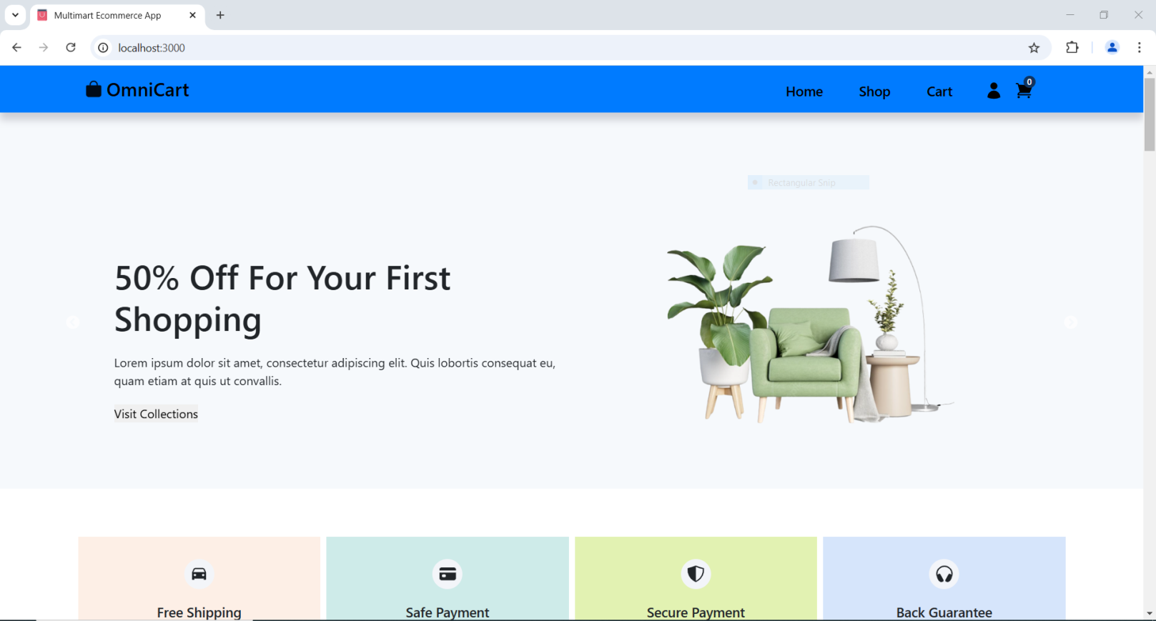

**Items Available in Sale**

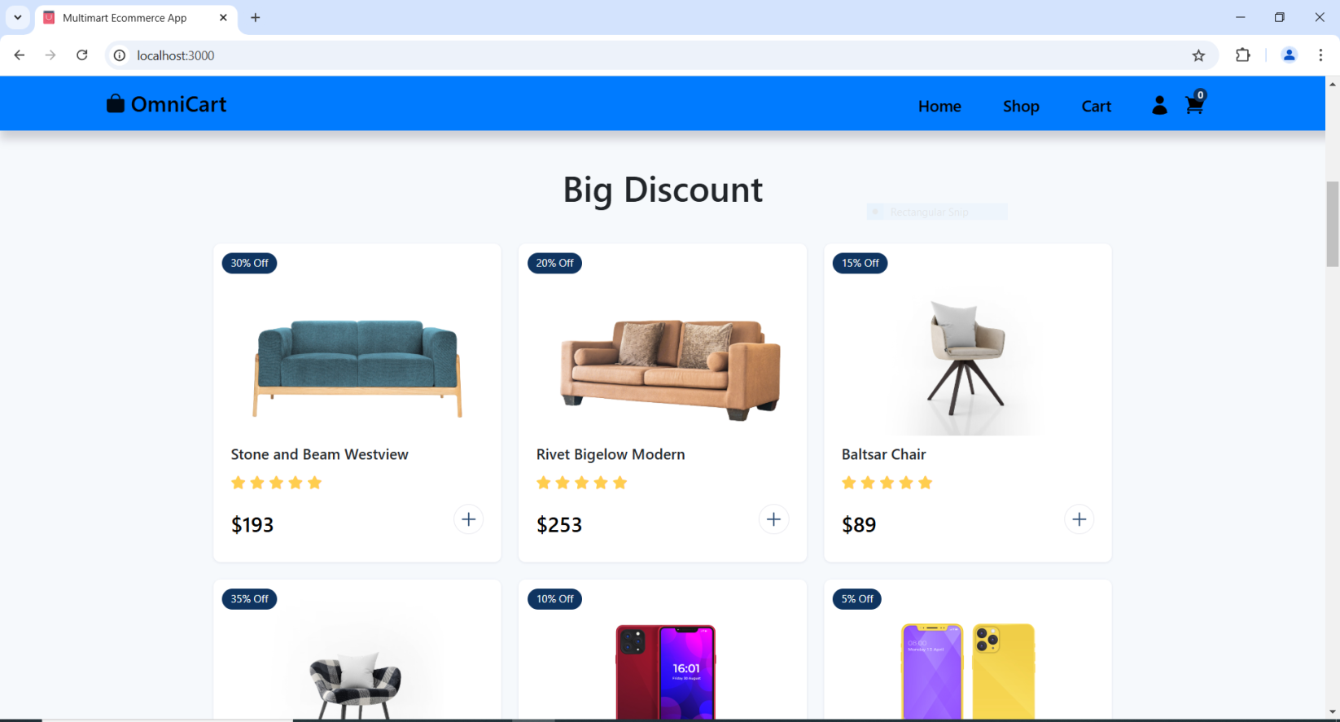

**New Arrival of Items Like Mobile,Apple Iphone With Cheap Prices**

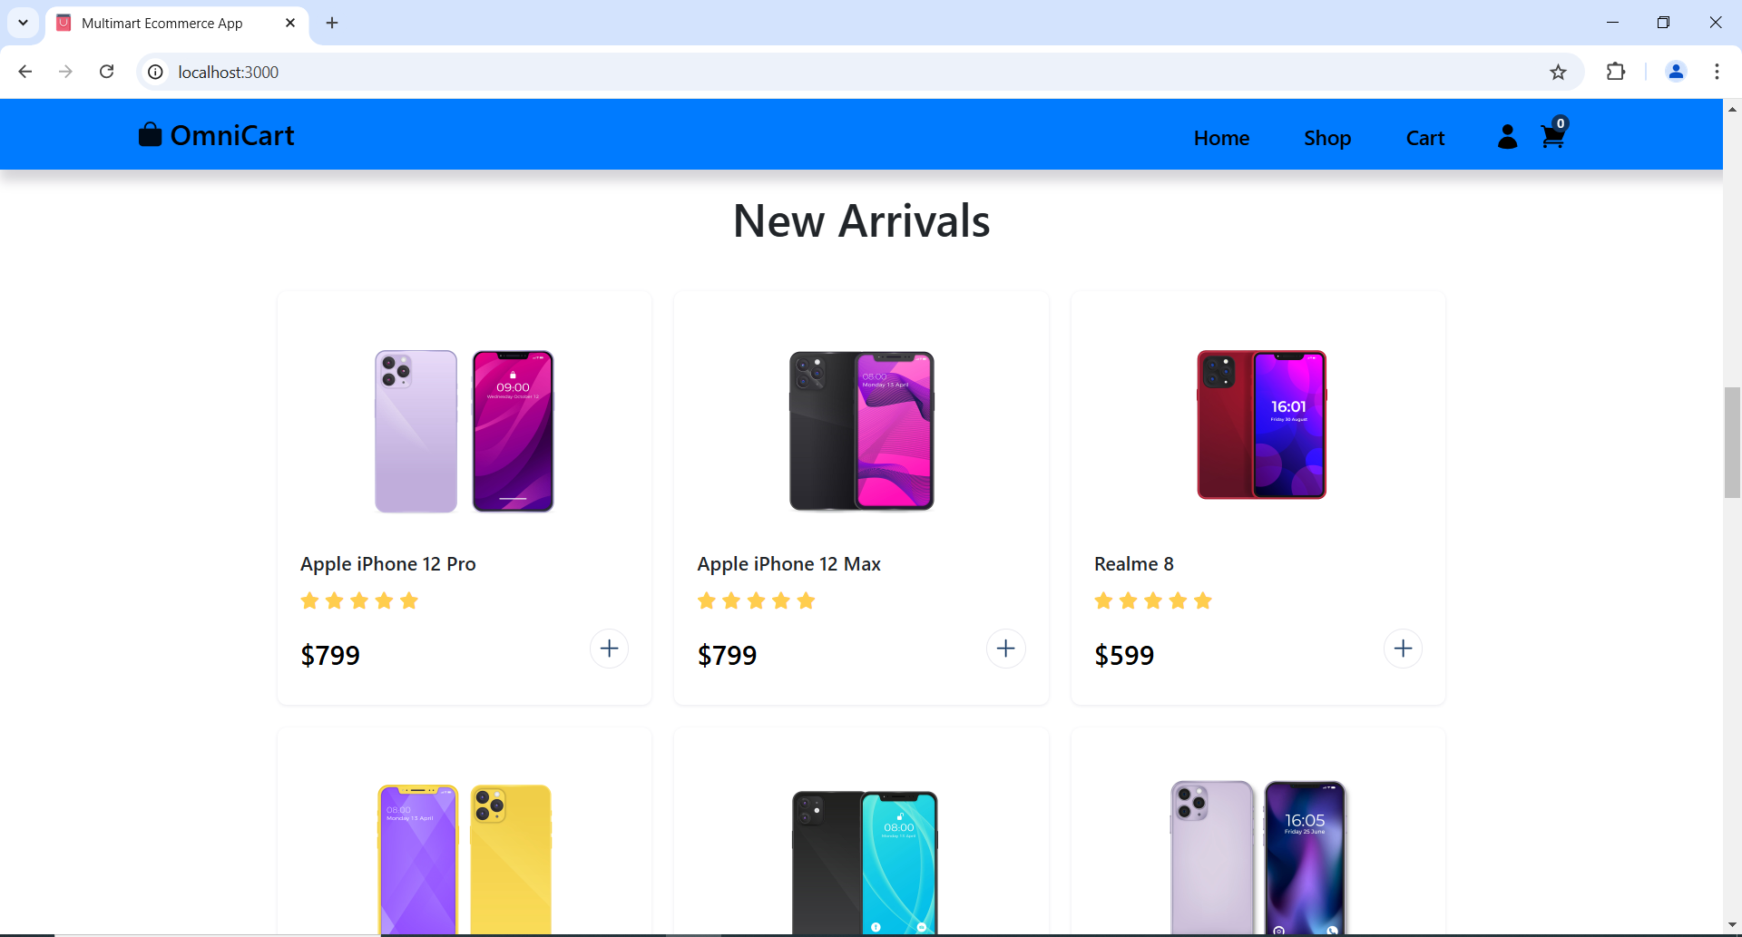

**Omni Cart Online Shopping Experience for More Products Like Arm Sofa(About Us and Customer Care)**

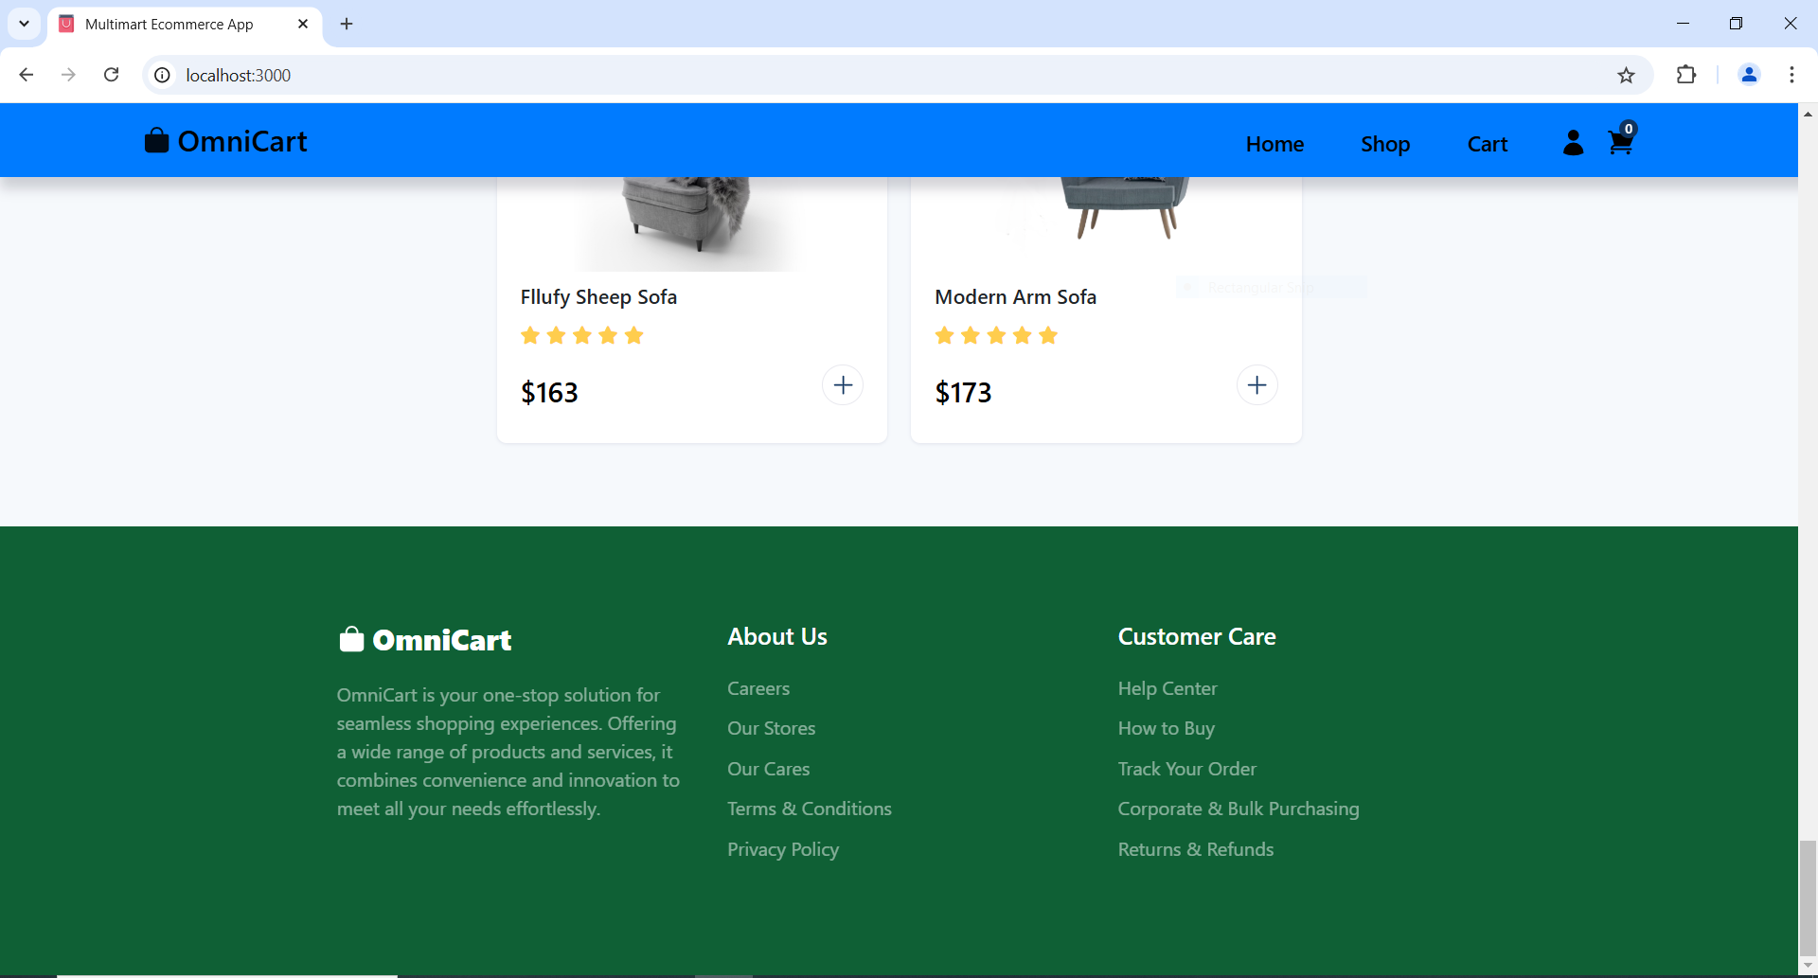

**Shop Page Available Stock of Many Items For Example Watches For Customers**

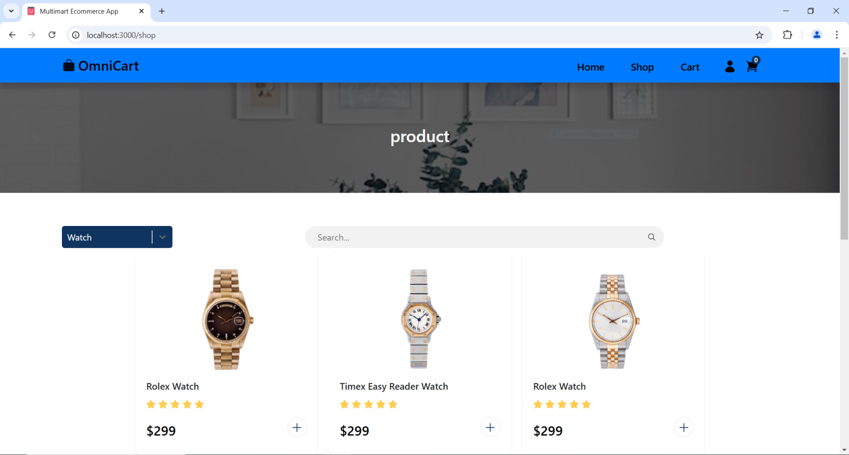

**Omni Cart Online Shopping Benefits for More Exciting Items Like Expensive Watch Collections and User Feedback**

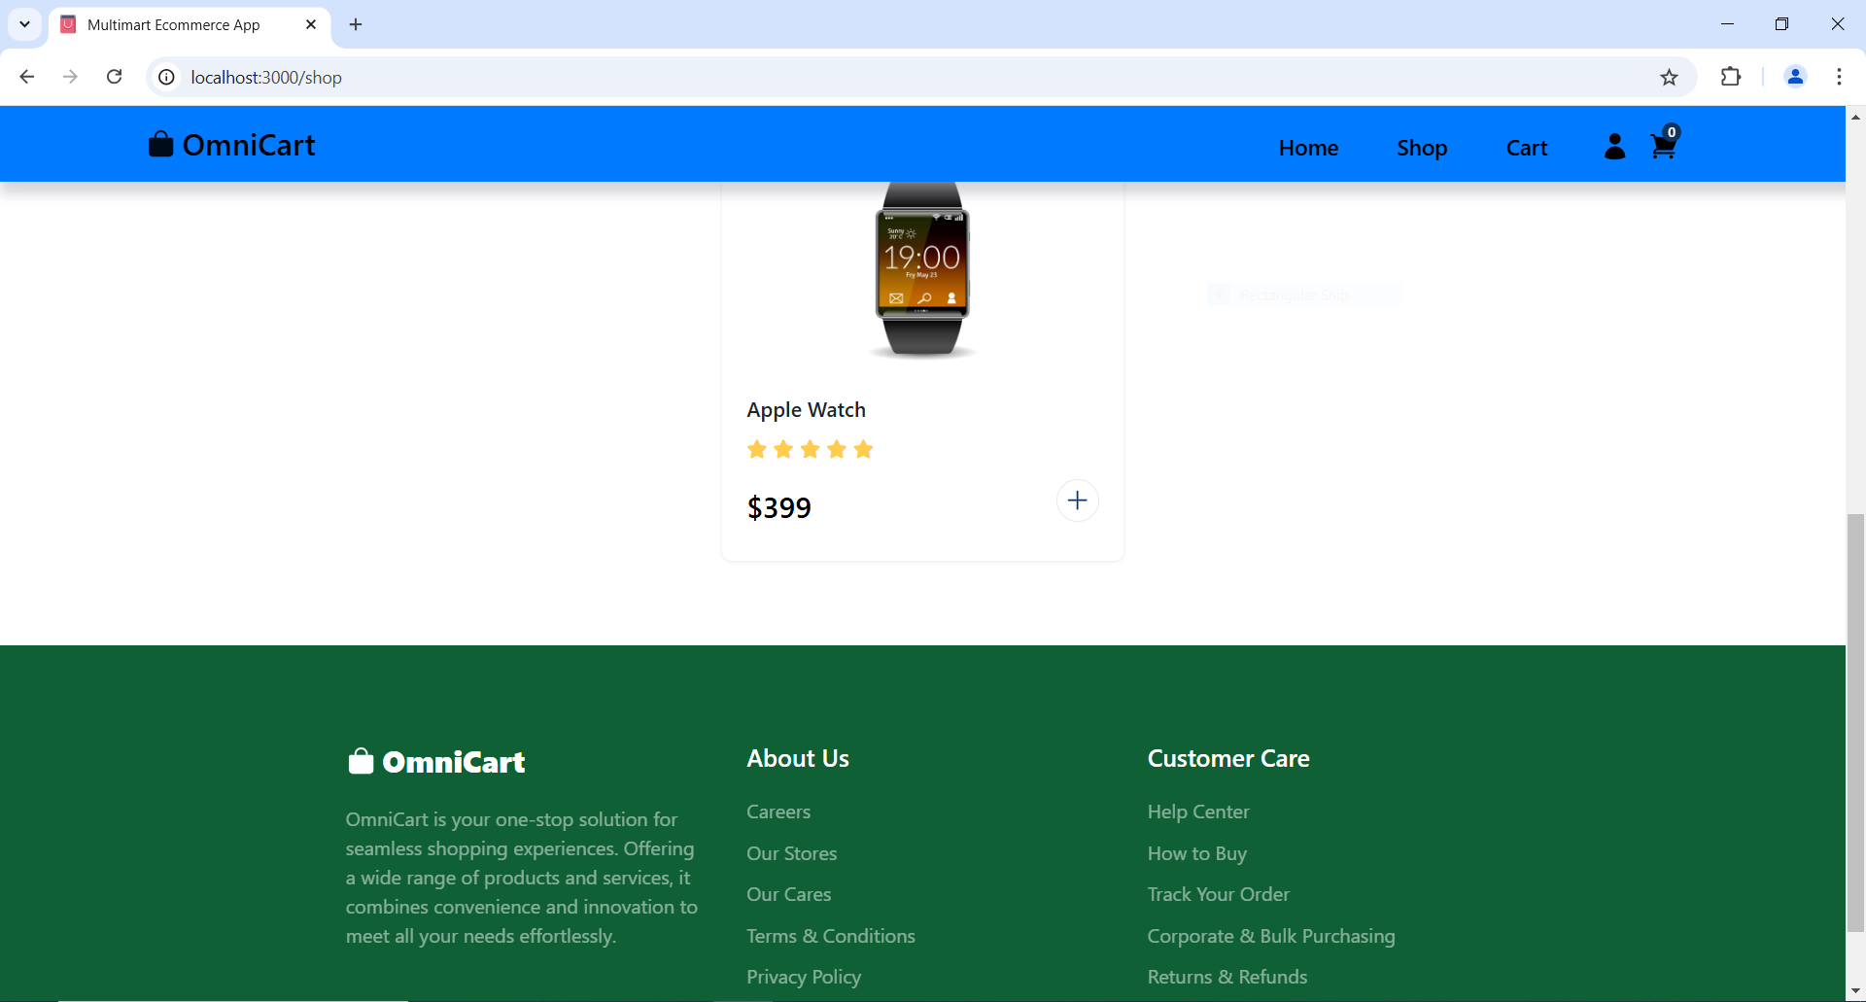

**Omni Cart Customer Satisfaction from Items 🡪 Items Not Added in Cart to Buy.**

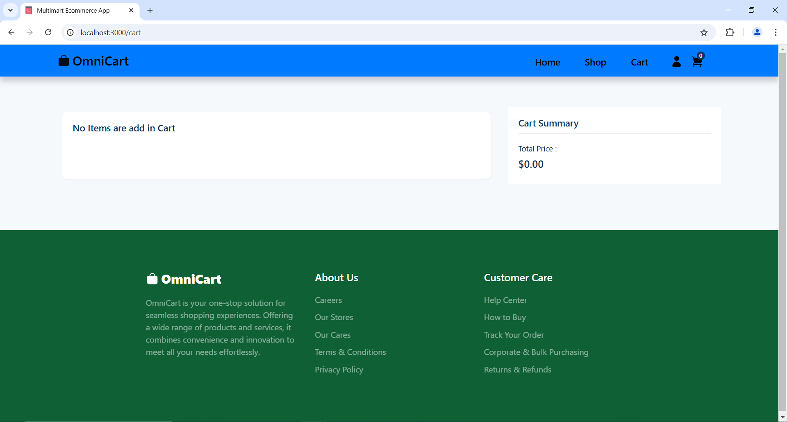

**Customer wants any Item “Product has been added to cart!”.**

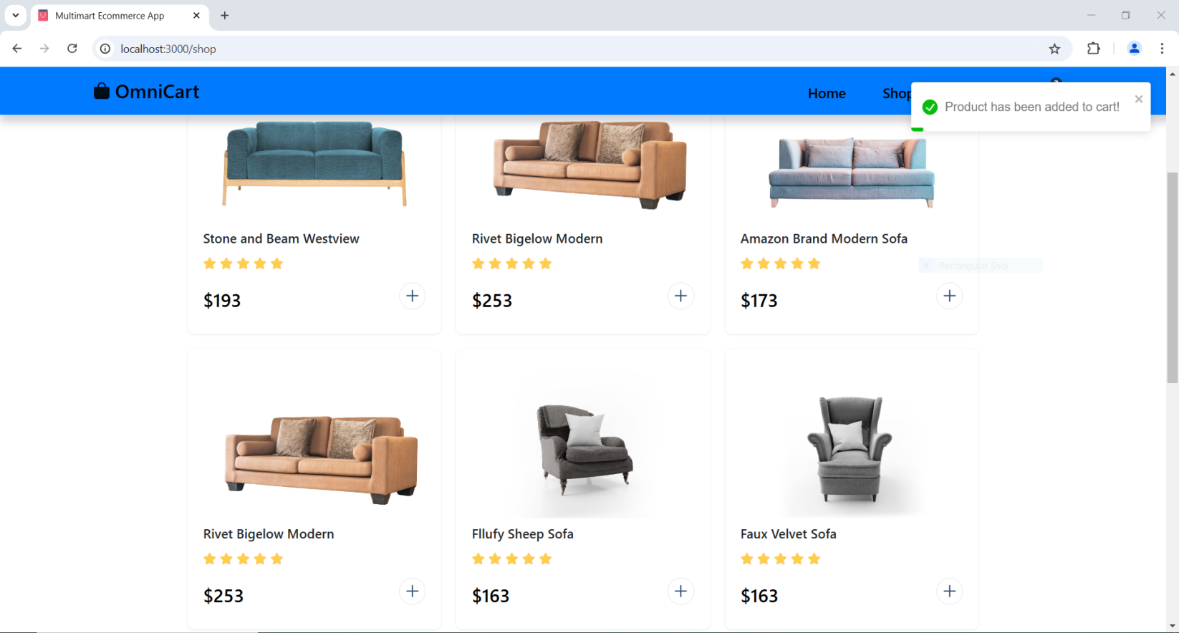

**Omni Cart Customer Satisfaction from Items 🡪 3 Items Added in Cart to Buy.**

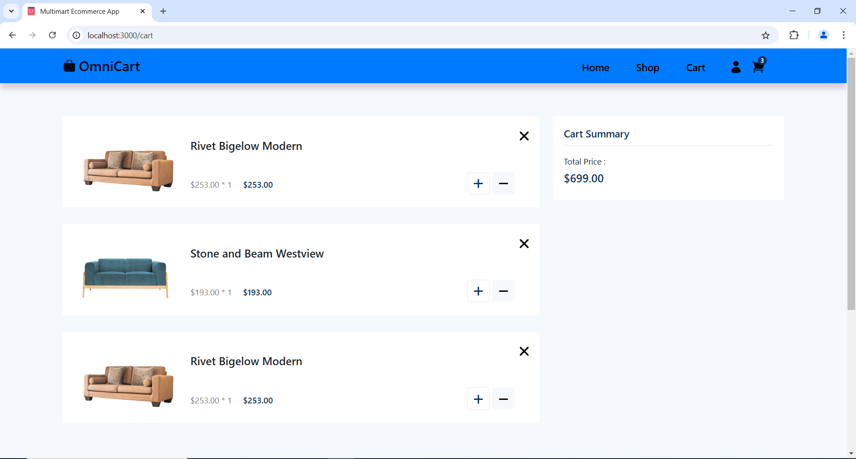

**Important Definitions/Commands**

**Product Catalog:**

The organized compilation of every product that a shop or online store sells is known as a product catalog on e-commerce platforms. Customers can use it as a virtual inventory to peruse and choose items to buy. Because it offers comprehensive information about every item, the product catalog is an essential component of any online shopping platform that helps users find, assess, and make well-informed judgments about what to buy.

**Search Features**

E-commerce websites search functions are vital resources that let customers locate goods fast and effectively. Customers may find exactly what they're looking for even if they don't know the product's name or other specifics thanks to an effective search tool, which improves the purchasing experience. The purpose of these features is to enhance user experience, boost engagement, and eventually increase sales.

**Shopping Carts**

On e-commerce websites, a shopping cart is a virtual container where users can gather and examine the products they want to buy before checking out. It is among the most essential components of online shopping platforms and is essential to provide a seamless and convenient buying experience. The "Add to Cart" button, for instance.

**Secure Payment**

The use of technologies, protocols, and tactics to guarantee that financial transactions between the consumer and the online retailer are secure, encrypted, and fraud-proof is known as "secure payment" in e-commerce websites. Because it increases consumer trust, protects data privacy, and lowers the possibility of financial fraud, secure payment is an essential component of online buying.

Events,ListItems,CartItems,Shopping Carts,Checkout,WishList,Item Categories,Login Card,Item Card,Rgeister Card,Header and Footer 🡪   
  
  
Files and Commands are used in this Project of E-Commerce Website as Project is made on React on FrontEnd and Backend Database MongoDB.